**The University of New Mexico**

**School of Engineering**

**Electrical and Computer Engineering Department**

**ECE 535 Satellite Communications**

**Student Name: Alex Hostick**

Student SN: 2O1

Module # 8: 8.3, 8.4, 8.5, 8.6, 8.8, 8.9

Fall 2023

**Prof. Tarief Elshafiey**

**8.3 Why is it desirable to downconvert the satellite TV signal received at the antenna?**

Downconverting the signals from a higher frequency to a lower frequency helps reduce the logistics costs of receiving the signal (e.g., cables, receivers). Downconverting, with DBS systems, allows for demodulation at the 70MHz frequency band.

**8.4 Explain why the LNA in a satellite receiving system is placed at the antenna end of the feeder cable.**

Low-noise amplifiers (LNA) are meant to amplify the signal without degrading the signal-to-noise (SNR) ratio. Placing the LNA at the end of the feeder cable will not only amplify existing noise observed by the receiving antenna but also the thermal noise of the connected cable.

**8.5 With the aid of a block schematic, briefly describe the functioning of the indoor receiving unit of a satellite TV/FM receiving system intended for home reception.**

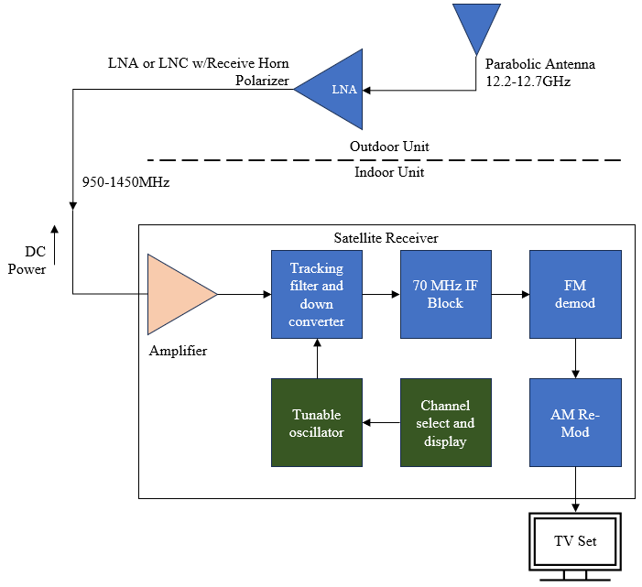

For indoor units used for analog (FM) television receives the 950-1450MHz signal from the downconverted outdoor received signal. The amplifier also provides DC power via RF cable to the LNA/C unit.

The satellite receiver will have half of the 32 channels present, due to polarizing interleaving, but eases the job of the tracking filter as channels are separated in frequency. Then, the satellite receiver will downconvert the signal to 70MHz intermediate frequency (IF), enabling the demodulation of the DBS TV frequency modulated (FM) signal.

**8.6 In most satellite TV receivers the first IF band is converted to a second, fixed IF. Why is this second frequency conversion required?**

For analog DBS TV receivers, the satellite receiver will downconvert the signal to 70MHz intermediate frequency (IF), enabling the demodulation of the DBS TV frequency modulated (FM) signal. The power required to carry out demodulation of the FM signal is also a factor.

**8.8 Describe and compare the MATV and the CATV systems.**

Master Antenna TV (MATV) is used to provide reception of DBS TV/FM channels to a small group of users. It consists of a single outdoor unit (antenna and LNA/C) feeding a number of indoor units.

Community Antenna TV (CATV) can provide reception to fewer users. CATV utilizes separate feeds for polarization like MATV. Received carriers are demodulated a common receiver-filter system and then combined into a standard multiplexed signal for transmission over cable to subscribers.

MATV advantage is that only one outdoor unit is required, but separate LNA/C feeder cables are required for each sense of polarization. A larger antenna (2-3m diameter) would be needed to maintain a good signal-to-noise ratio. In contrast, CATV can use less feeds for the system with the receiver-filter system. CATV systems can also provide local programming which MATV cannot.

**8.9 Explain what is meant by the term redundant earth station.**

Redundant earth stations are transmit-receive stations used as redundant and duplicated systems that automatically switched into a circuit to replace a corresponding unit that has failed. Carriers can be received in multiple locations, and redundant links can ensure the traffic reaches a receiver if one is degraded, has heavy communication traffic, or the hardware failures in the link. Multiple battery power supplies are also used in the for redundant power supplies.

Nominal uplink frequency is 6GHz/14GHz while the downlink is 4GHz/12GHz in the C and K band, respectively.